Sample application form
Before proceeding with the online application please read the following information:
- Use latin characters for the file names or description of certificates / diplomas; avoid the use of special characters or for example Greek characters.
- You can only use the upload button for a Europass CV created from the relevant page on our website and saved as pdf+xml. If you upload the Europass some fields in your application will be filled in automatically; in this case first upload the Europass and then fill in the rest of the information manually;
- If you do not wish to use the Europass created and saved in pdf+xml format you may attach your CV in the required files (together with your university title and any other document) at the bottom of your application, using the relevant button before submitting it. Attach only the following formats: .doc, docx, pdf , .rtf, .txt, .jpg, jpeg, tif, .tiff, .png, .gif, .xls, .xlsx, .ppt, .pptx, .xml, .html, .htm in order to ensure that your attachments are readable and duly inserted in our system. Maximum size for attachments is 4MB;
- If the CV (in English) or the undergraduate university degree (in any EU language) is missing the application will not be considered.
Candidates have the sole responsibility for filling in their application correctly and attaching the necessary documents in a correct format. When the application is submitted candidates are requested to print out the relevant page created by the system where they can see all relevant information they provided as well as the number of documents they attached.
An acknowledgment e-mail is sent to the candidates. The Human Resources will not check the correct submission of applications or the number of attachments provided by the candidates and cannot modify the applications as submitted by the candidates. If you do not receive the acknowledgment e-mail with your protocol number or if you have submitted an incomplete application you may apply again and you will receive another protocol number. Once an application is submitted you can no longer edit/change it.
Make sure you insert correct contact details (telephone(s), address, e-mail).
Please see the sample application provided in the next pages bearing in mind that all fields marked with * are obligatory:

1. First screen
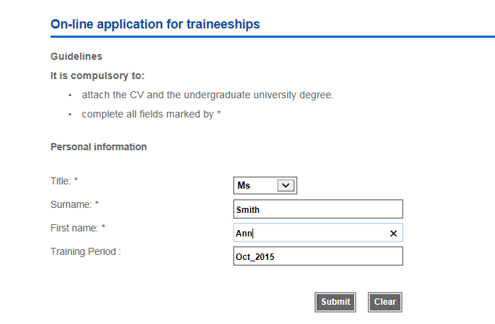
- Select title (Mr, Ms)
- Type your surname and forename in the relevant boxes
- Click on ‘submit’ to proceed to the next screen or clear if you wish to correct your data

2. Second screen
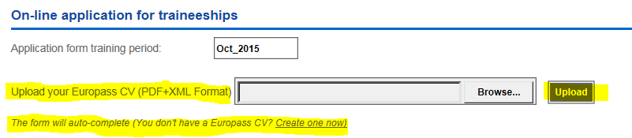
- You may only use ‘upload button’ if you create a new Europass CV and save it in pdf+xml format. In this case some data will be filled in automatically in your application. You may then proceed with the rest;
- Do not try to upload any other attachment in this field. For all other attachments (Certificates, CVs in other formats, or other relevant attachments, you must use the relevant button at the bottom of the second screen as described further below;
- Fill in the required information and then attach your documents by clicking the relevant icon (highlighted below) before you click on ‘submit’.

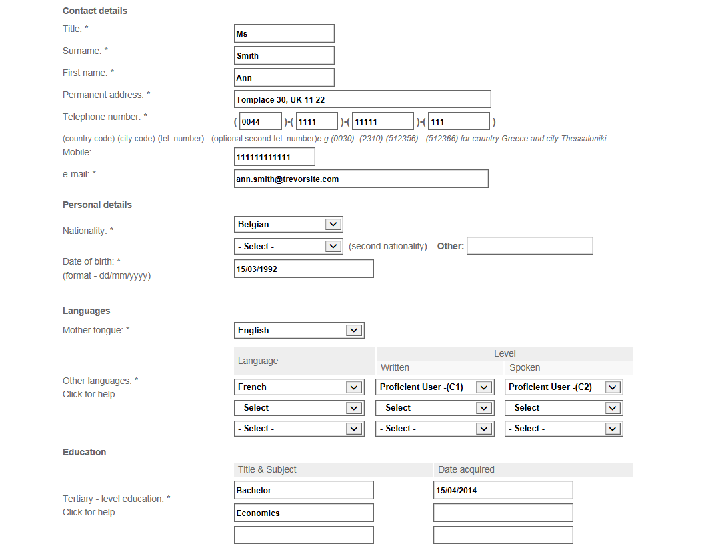

- Click yes or no in previous traineeships:

- Choose up to three projects of interest in order of priority and answer the relevant questions:

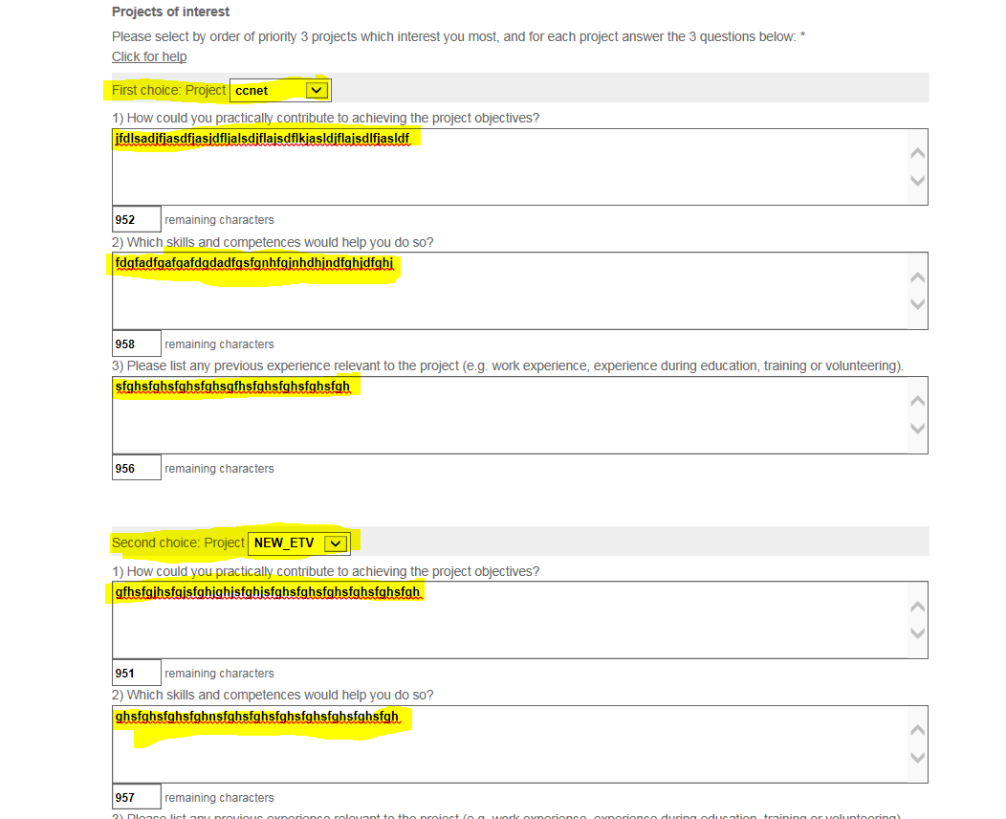

- Do not forget to attach the required files (and any additional ones you want) and check that they are readable:
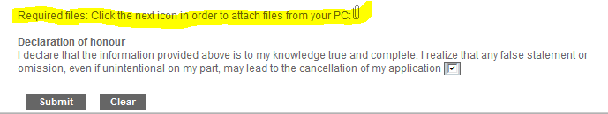

When you click on submit you will be asked to confirm that the data and attachments you inserted are correct:
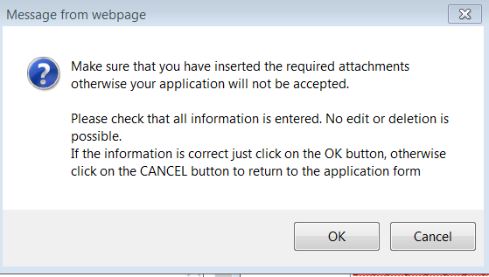
- Click on the ‘ok’ button;
- The following screen will appear:
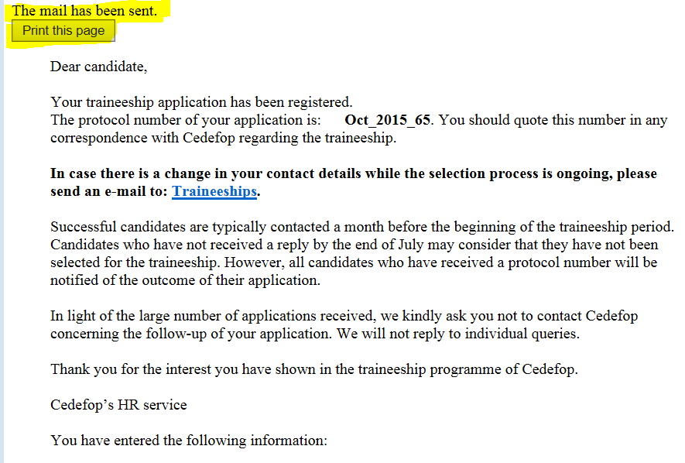
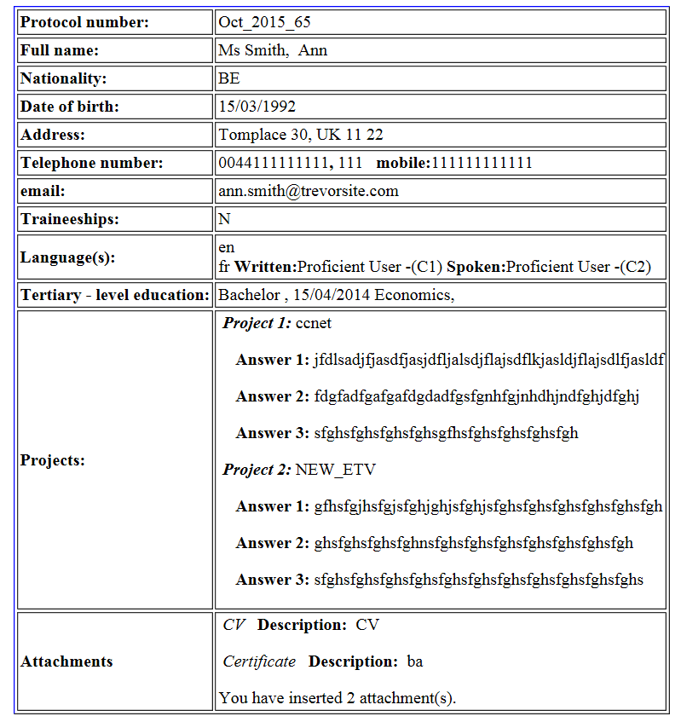
- Print the above page where you can see the number of attachments you inserted as well as the rest of your data;
- You will receive the following automatic e-mail confirming that your application has been submitted. Please do not respond to it.

