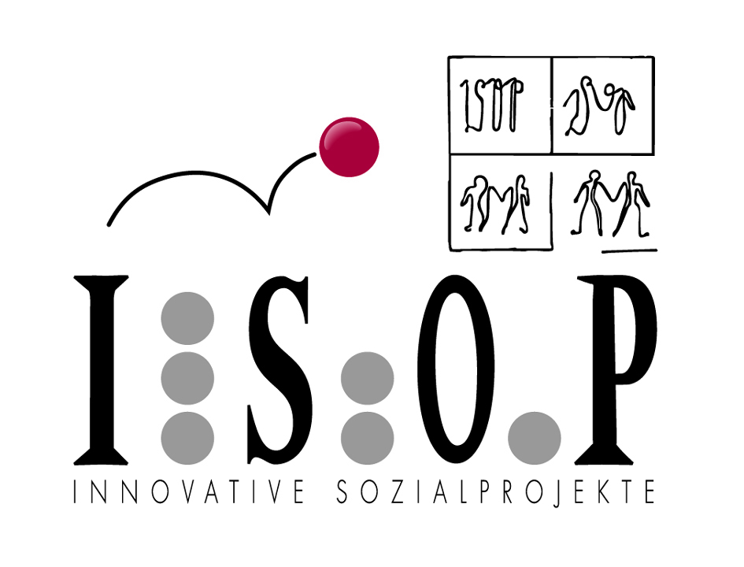Guidance for raising competence levels of migrants in Austria
Silvia Göhring, Austria
Structural background in Austria
- no standardised, nationally recognised procedure
- no clearly defined concept for the integration of immigrants
- outsourcing of integration-related activities to privately run organisations in the social and education sector
  - the quality of service provided is dependent on two factors:
    - the organisation’s level of knowledge and experience
    - the creativity of the organisation also with regard to funding efforts
      - The unfortunate upshot of this is that the activities – independent of their quality – are rarely planned as anything more than short-term projects. Long-term planning and development is difficult, meaning that there is no continuity in the development process – A back-to-square-one situation ensues where similar activities are carried out elsewhere. Naturally, questions of sustainability, quality, stability, etc. will arise from a situation like this.
ISOP-Innovative Sozialprojekte (www.isop.at)
- Founded in 1987, active in Styria at regional and local level
- Providing education for immigrants since 1989
- 180 employees work in 40 different projects in the following areas:
  - Counselling
  - Learning
  - Employment
  - Children and youths
- Target groups include both immigrants and Austrian citizens
  - Some activities are set up exclusively for immigrants and others are for both groups.
- Funding: various provincial and national government departments, local councils, AMS Steiermark (Public Employment Service), ESF
ISOP-Activities
- Counselling: Social welfare advice, legal advice concerning Austrian immigration laws, assistance in dealing with the authorities and any associated paperwork, assistance during visits to doctors and hospitals, support for job seekers, education counselling for adults and young people
- Learning: Basic education (reading, writing, mathematics, computer literacy, etc.), attainment of the compulsory education certificate as a prerequisite for vocational training, courses in general German and German for specific purposes, vocational training for immigrant women in the areas of patient care, logistics, and marketing and sales management, Diversity Mainstreaming seminars and Basic Education seminars for teachers
- Employment: ISOP provides temporary employment (9 – 12 months) in the following: ISOP’s own canteen and catering service, childcare, caretaker, teaching, and in other ISOP projects depending on the qualifications of the individual. During the period of temporary employment, people are given careers advice and can take part in various courses (German, etc.)
- Children and youths: After-school care, school social work, youth clubs, social street work, youth work

Project presentation – good practice:
Competence profile analysis and education counselling for immigrants

Background and motives for project development
- Generally poor employment prospects for immigrants (unemployment levels for immigrants are twice as high as for white people born in Austria)
- Difficulty to use qualifications attained abroad in the Austrian labour market
- Barriers to official recognition of qualifications attained abroad (costs of procedures, length of procedures, missing certificates, etc.)
- Unskilled employment despite having qualifications
- Mainly mono-culturally oriented education in vocational training organisations
- Non-recognition of informal qualifications and skills
- Difficulty for potential employers to assess professional skills without formal certificates
Definitions
- Competences – A combination of professional, social and personal skills which are needed to carry out given tasks in specific situations.
- Competence profile – A structured analysis of the competences of a given individual. Every person has at their disposal a pool of competences and resources (often unknown to themselves). Skills and competences are outlined with regard to specific external requirements. In our case these requirements are dictated by the labour market.
- Education counselling – The formulated competences and resources are activated and appropriate information is made available. In doing so, the individuals are made aware of their potential.
Project structure
- Funding: 50% ESF, 50% AMS Steiermark (Public Employment Service) and The Styrian Provincial Government
- Duration: 2 years (2010 – 2011)
- Target group:
Immigrants with
- legal access to the labour market
- vocational qualification in the country of origin and/or
- work experience in the country of origin and/or Austria
- German language at level A2 according to the Common European Framework of Reference for Languages

- Admission to the project through
- the AMS
- Social Services Department Graz
- Organisations such as self-organisations of immigrants and education institutes

- Length of attendance
- 8 weeks
  - 6 weeks group counselling phase (8 – 10 participants, 9 hours/week), = Competence Profile Analysis
  - 2 weeks individual counselling phase (5 – 10 hours)

Objectives
- Project objectives
  - Uncovering existing job-related competences aside from formal certificates
  - Improvement of competence transfer
  - Helping to change attitudes towards the target group
  - Raising the quality of placements on the labour market
  - Reduction of cases of unskilled work for well qualified individuals
  - Acceleration of processes for labour market integration

- Objectives of the target group
  - Discovery of one’s own strengths and opportunities and to build on these
  - Self reflection
  - Achieve clarity with regard to transfer obstacles
    - develop strategies to help to find employment
    - to put newly acquired knowledge into practice
    - Self-confidence

=Self-concept: increase in awareness of one’s own opportunities
=Self-drive: empowerment enhancement

Contents
- Competence –portfolio:
  - Curriculum vitae: reflect upon and describe different phases of one’s life
  - record of achievements: listing occupations, reflection and assessment
  - describing learning processes and drawing conclusions
  - personal profile:”I can...!” “I am...” and giving reasons
    - What have I done so far?
    - How did I do it?
    - What were my functions?
    - Which attributes did I need to perform the tasks?
      - Formal, non-formal and informal competences are identified, described and assessed. These are then bundled and used to plan the individual’s education and employment targets.
- Further career steps: Prospects and action plan

- Qualification portfolio – systematic collation of proof of activities

- Education and further education
- Employment
- Family related work
- Voluntary work
- Free-time activities

- Job Application Portfolio – Presentation of competences

- Curriculum Vitae
- Competence profile in accordance with the job description
- Further job application documents

Methods
- A combination of group and individual counselling
- Connecting phases of social learning (group work) with phases of individual learning
- Facilitating lively group processes
- Emphasis is placed on the processual nature of the project, responding adequately to the needs of the individual participants without losing sight of the end objectives.
- Framework: describing, recognising, proving, applying
- Guided reflection
- Self reflection and research
- Presentation
- Feedback
- Evaluation: Assessment of learning success, putting newly acquired knowledge into practice

Strengths compared with similar mainstream services
- More intensive support and counselling
- Language issues are taken into consideration. (non-native speakers)
- After-course support and staying in contact
- Further characteristics: Transparency, openness, mutual willingness, no emphasis on written materials, positive attitude, respect

Facts and figures (May 2010 – July 2011)
Quantitative results:
- 92 participants, percentage women 71%
- Results immediately after end of counselling (normal day of data retrieval is 92 days after leaving an AMS course)
  - 49% have a definite result
    - 80% of these either attend vocational training or are in the process of having their qualifications recognised, 20% are in employment
Qualitative results:
- Clarification of competences and reality check
- Improvement of skills in self presentation and rhetoric
- Increase in job-market-related and specialist vocabulary in German
- Increased motivation
- More self confidence and belief in one’s own competences
- Increased access to further education due to the portfolio of competences

Participants’ comments
“At first I didn’t actually know what I was doing here. Now I feel as though my head has woken up. It had been asleep for years.”

Lessons learnt
Participants
- Target-group-oriented projects v. mainstream institutions: The nationwide evaluation of ESF has revealed conclusively that mainstream institutions experience great difficulty in reaching immigrants in spite of the fact that they have defined immigrants as a target group. In groups where there are immigrants and non-immigrants, it has been shown that immigrants are less likely to contribute actively. (reasons given: language insecurities). This means that they are less involved in the course. Mainstream institutions find it difficult to work effectively with linguistically heterogeneous groups, i.e. their methods do not meet the needs of immigrants.
- Immigrants have a heightened interest in the improvement of their lives and are almost always realistic and guided by reason.

Structure and system
- Implementation of educational plans: Immigrants are rarely in a position, due to their socio-economic situation, to finance their own further education. This means that they are dependent on the willingness of the state to provide the necessary funding. Experience has shown that the more complex or unusual the education plan is, the less forthcoming is the willingness to provide funding. This is not only a question of costs.
Other barriers include family related issues, e.g. childcare has not been arranged.
  - Solutions for implementation and further development: All further steps which have been checked for feasibility should be funded. The whole system of funding should also be looked at. Currently in Austria, the AMS is mainly responsible for funding. However, the AMS has a very clearly defined mandate (unemployment). Other organisations and government bodies are rarely available for funding. This is, incidentally, not only an issue for immigrants, but also for the long-term unemployed and people with a lower level of education. Another crucial factor is the development of structured partnerships over and above existing informal alliances. This means that questions relating to communication, roles, responsibilities, etc. have to be answered.

- Voluntary participation: Unemployed people in particular are also sent by the appropriate authorities. Others who are not “in the system” cannot be reached.

  - Solutions for implementation and further development: Rethink admission procedures in order to make the programmes more accessible.

- Process of integration: The evaluation of the programme has shown that individual needs assessments should be carried out at the beginning of the integration process. Currently this is only done randomly.

- Solutions for implementation and further development: Coordination of planning processes and creation of appropriate educational structures.
Recognition of competences: As long as programmes such as this one do not rise above their project status, the recognition of the results of the procedures will be undermined. It would be particularly helpful if a binding, trans-regional strategy or policy could be put in place, which would create an appropriate clear framework. Within this framework, the procedures and the value of the results could be defined in relation to existing mainstream educational standards.

